ITEM DETAILS
Name of Item | Inter-War Cecil Flats
Other Name/s  Former Name/s | 10 Francis Street, Bondi Beach (also 1 Edward St)
Item type | Built
Item group | Flat Building
Item category | Flat
Area, Group, or Collection Name | Unknown
Street number | 10
Street name | Francis Street
Suburb/town | Bondi Beach |  |  |  |  | Postcode |  |  | 2026
Local Government Area/s | Waverley
Property description | SP 30919
Location - Lat/long | Latitude | -33.894603 |  | Longitude | 151.27166
Location - AMG (if no street address) | Zone |  |  | Easting |  |  |  | Northing
Owner | Private
Current use | Residential
Former Use | Residential
Statement of significance | The Cecil, 10 Francis St / 1 Edward St Bondi is a fine and intact example of a four-storey Federation Arts & Crafts-style flat building that demonstrates the development of Bondi Beach in the early Inter-War period.  It represents the development of Inter-War flat buildings, an important phase in the history of Waverley which represents the 1920s-1930s development boom, a prominent period of economic prosperity and speculative development in Waverley associated with the changing demographics with a shift to living in flats.  The Cecil provides a notable example of residential flats adapted for families which is rare in Waverley and other local government areas.  It has historic associations with A.M. Lowenthal, Waverley businessman and Alderman.
Level of Significance | National |  | State |  |  |  | Local

DESCRIPTION
Designer | Claud Hamilton
Builder/ maker

Physical Description | The Cecil at 10 Francis St / 1 Edward St Bondi, is a four-storey Federation Arts & Crafts-style flat building that is part of a group and outstanding in its precinct. The building displays features of the Federation Arts & Crafts style including face brick, rough-cast wall finishes, circular windows, timber brackets, brick details, stepped parapet, battered pergola piers and sleepout verandahs. The building is setback 15 metres from Francis Street and 8 metres from Edward Street on a large, elevated site ranging from 20-30 metres wide, that has been resubdivided in a suburban setting that has retained much of its historic context. The building is in excellent condition and highly intact. The five (5) garages and a set of steps present to Francis Street. A pergola and low face-brick fence which compliment the setting of the place are located on Edward Street.
Physical condition  and  Archaeological potential | The building appears to be in excellent condition.
Construction years | Start year | 1919 | Finish year | 1919 | Circa
Modifications and dates

HISTORY
Historical notes | 10 Francis St / 1 Edward St Bondi were part of the Bondi Estate, subdivided in 1879 as DP 411, the site is Lot 34 Section 2 in DP 411. Francis O’Brien mortgaged part of DP 411 to English Scottish Australian Bank Ltd in 1896 (917-176). Lots 34-39 were purchased from the mortgagee exercising power of sale by Normal Fitz, a teacher, in 1911 (2213-190). The site was purchased by Abraham Marcus Lowenthal, Waverley businessman and Waverley alderman, in September 1919 (2834-10). It was resubdivided under DP 342611. Plans for the flats were prepared by Claud Hamilton for A.M. Lowenthal in May 1919. The building comprised 11 flats ranging from 1 to 3 bedrooms with sleep-outs, based on those utilized in large family residences at the time, and providing garages set into the lower slope. Newspaper articles of the period record Lowenthal’s intention to provide flats for people with children. The grounds provided “ample space for a tennis court, cubby houses, swings and children’s other amusements. Each tenant is allotted a small piece of land for growing vegetables and a row of poultry yards is stocked with very fine birds.” (Sydney Morning Herald Wednesday 22 June 1921 page 9)

THEMES
National  historical theme | 4 Building settlements, towns and cities  8 Developing Australia’s Cultural Life  9 Marking the phases of life
State  historical theme | Towns, suburbs and villages  Land tenure  Accommodation  Domestic life  Creative endeavour  Persons
Local  historical theme | Leisure and Recreation  Flats and Bungalows

Assessment
A: Historical Significance | The Cecil, 10 Francis St /1 Edward St Bondi, has historical significance at a local level as it represents the development of Inter-War flat buildings, an important phase in the history of Waverley which represents the 1920s-1930s development boom, a prominent period of economic prosperity and speculative development in Waverley associated with the changing demographics with a shift to living in flats.  The Cecil provides a notable example of residential flats adapted for families which is rare in Waverley and other local government areas.
B: Associative | The Cecil, 10 Francis St /1 Edward St Bondi, has historical association significance at a local level as it has historic associations with A.M. Lowenthal, Waverley businessman and alderman. The research to date has not identified the architect Claud Hamilton as an important person in Waverley.
C: Aesthetic significance | The Cecil, 10 Francis St /1 Edward St Bondi, has aesthetic significance at a local level as a fine and intact example of a four-storey Federation Arts & Crafts-style flat building on a large, elevated site.  The building shows an accomplished use of Federation Arts & Crafts style which features face brick, rough-cast wall finishes, circular windows, timber brackets, brick details, stepped parapet, battered pergola piers and sleepout verandahs.
D: Social significance | To date no social, cultural, and spiritual significance has been identified.
e) Technical/  Research significance | To date no technical significance has been identified.
f) Rarity | The Cecil, 10 Francis St /1 Edward St Bondi, has rarity significance at a local level as it is a rare example of flat building adapted for family housing in Waverley and other local government areas.
g) Representative-ness | The Cecil, 10 Francis St /1 Edward St Bondi, has representative significance at a local level as a fine and intact example of a four-storey Federation Arts & Crafts-style flat building that demonstrates the development of Bondi Beach in the early Inter-War period.
Integrity | The building is highly intact.

HERITAGE LISTINGS
Heritage listing/s | Draft Waverley LEP 2012

INFORMATION SOURCES
Type | Author/Client | Title | Year | Repository
 | Waverley Council | Draft Waverley Heritage Assessment | 2020 | Waverley Council
 | Waverley Council | Waverley Heritage Policy | 2007
 | Waverley Council | Waverley Heritage Study | 1993
 | Perumal Murphy Pty Ltd | Waverley Heritage Study | 1990
 |  | Certificate of Title, Vol 917 Fol176 |  | NSW Land Registry Services
 |  | Certificate of Title, Vol 2213 Fol190 |  | NSW Land Registry Services
 |  | Certificate of Title, Vol 2834 Fol10 |  | NSW Land Registry Services
Newspaper articles | Sydney Morning Herald | Wednesday 22 June 1921, pg9 | 1921 | National Library Australia

RECOMMENDATIONS
Recommendations

SOURCE OF THIS INFORMATION
Name of study or report | Heritage Policy by Waverley Council reviewed by Architectural Projects 2023 |  | Year of study or report
Item number in study or report

Author of study or report
Inspected by
NSW Heritage Manual guidelines used? |  |  |  | Yes |  | No
This form completed by |  |  |  | Date

IMAGES

Image caption | 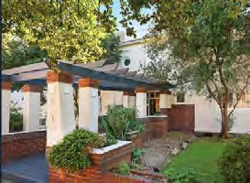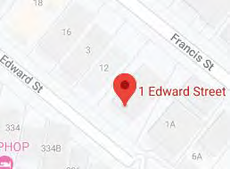
Image year |  | Image by | Google Maps | Image copyright holder

Image caption | 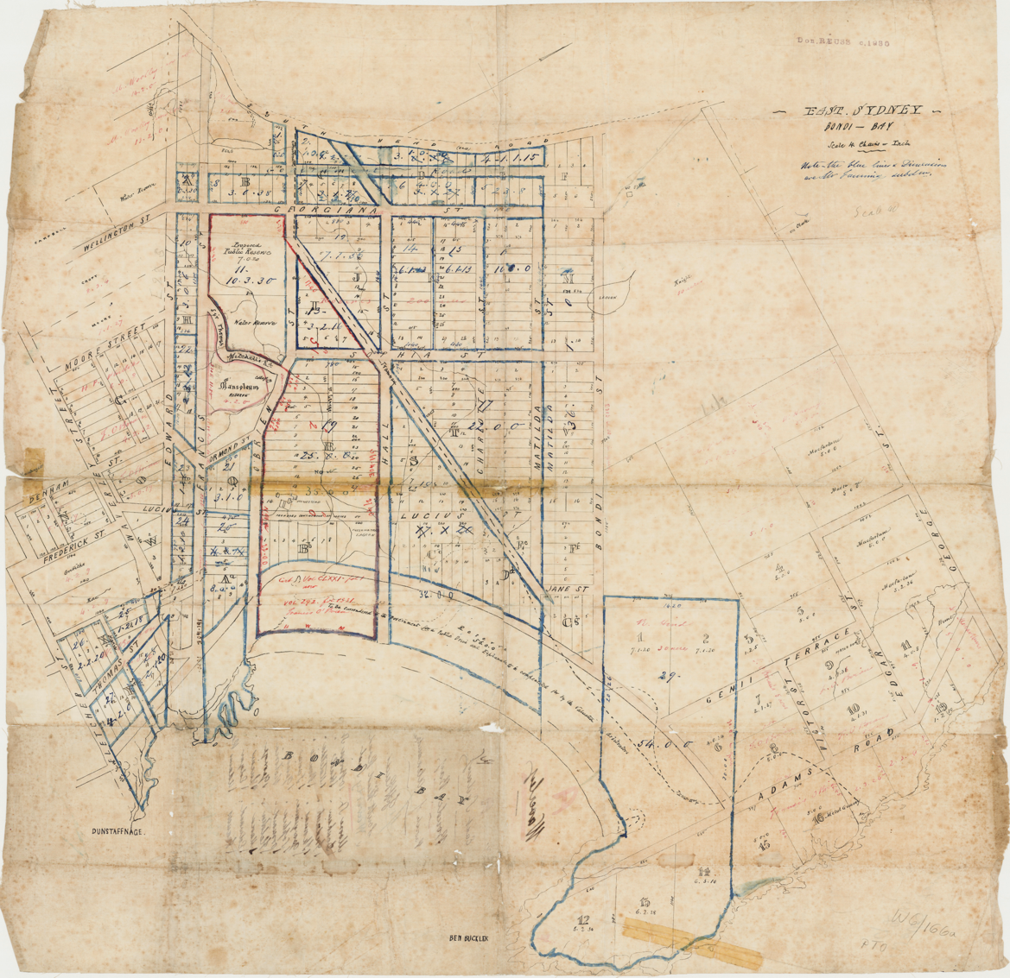
Image year | Undated | Image by | State Library of New South Wales | Image copyright holder

Image caption | 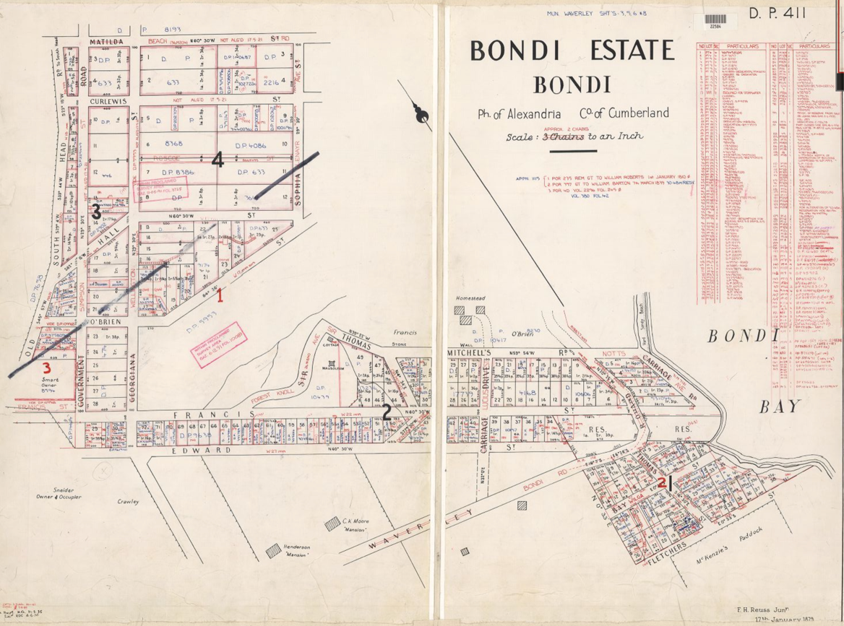
Image year | Undated | Image by | State Library of New South Wales | Image copyright holder

Image caption | 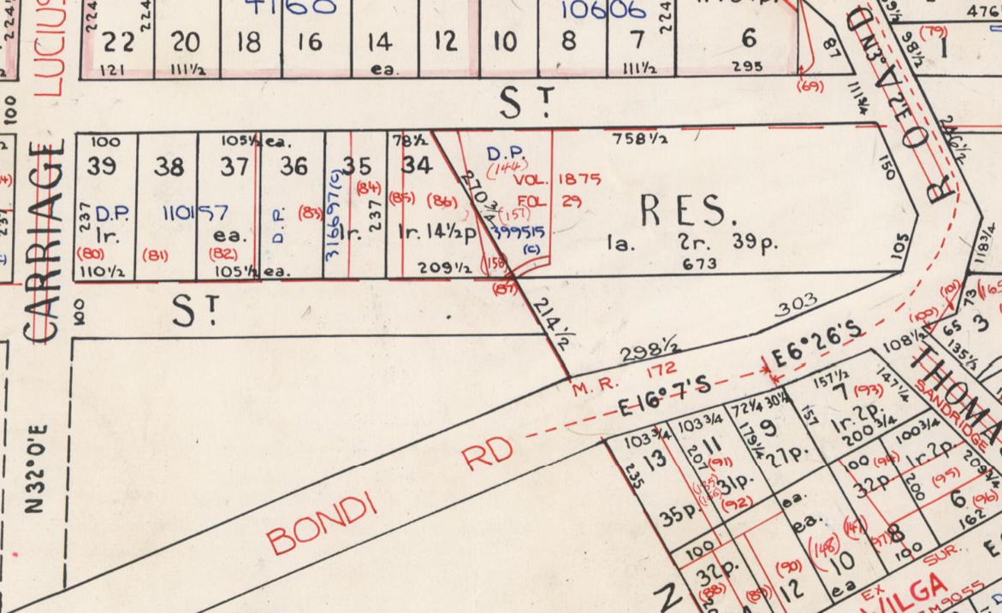
Image year | Undated | Image by | State Library of New South Wales | Image copyright holder

Image caption | 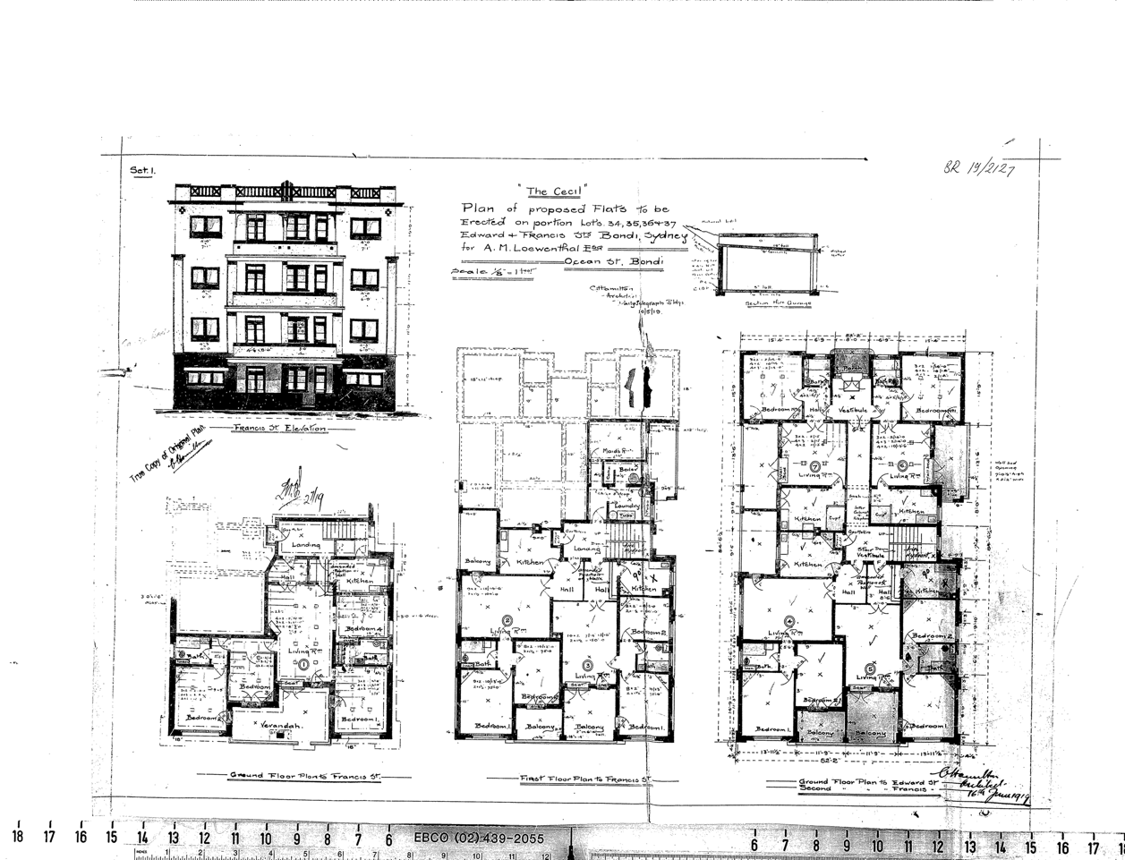
Image year | 1919 | Image by | Waverley Council | Image copyright holder

Image caption | 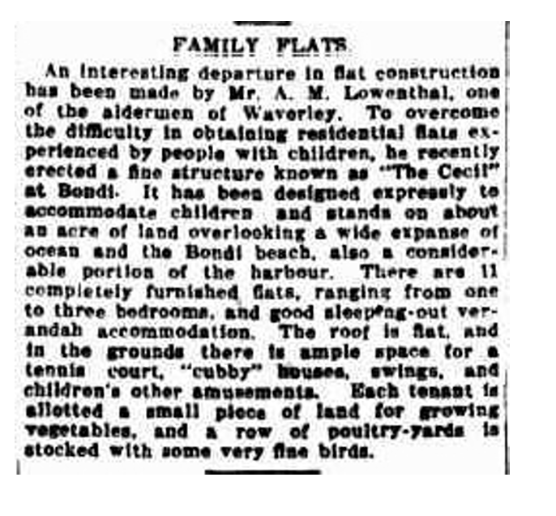
Image year | 1921 | Image by | Sydney Morning Herald | Image copyright holder

